

IT&BUSINESS COLLEGE
Department: COMPUTER SCIENCE
Project Title: CHUKO

Team members:
Toktogonov Daniel (ID: 238715027)
Instructor: Bolushov Erbol
Group: SCA-23C
TABLE OF CONTENTS
1. Abstract 4
2. INTRODUCTION 5
2.1 Problem Statement 5
2.2 Objectives 6
2.3 Scope - gameplay clarification: 6
3. TECHNOLOGY STACK 7
3.1 Frontend 7
3.2 Backend 7
3.3 Database 7
3.4 Infrastructure 8
4. SYSTEM ANALYSIS & DESIGN 9
4.1 System Architecture 9
4.2 Game Object Design 10
4.3 Physics System 11
4.4 Level Design 12
4.5 Wireframes / Visual Design 12
5. IMPLEMENTATION 13
5.1 Frontend Structure 13
5.2 Slingshot Input Handling 14
5.3 Chuko Types — Implementation 15
5.4 Multiplayer 16
5.5 Cultural Layer — Implementation 16
6. TESTING & RESULTS 17
6.1 Physics and Gameplay Testing 17
6.2 Cross-Browser and Device Testing 17
6.3 Multiplayer Testing 17
6.4 Live Demo — Application Screenshots 18
7. CONCLUSION & FUTURE SCOPE 21
7.1 Summary 21
7.2 Challenges 21
7.3 Future Improvements — Version 2.0 22
8. REFERENCES & APPENDICES 23
8.1 References 23
8.2 GitHub Repository 23
8.3 Live Deployment 23

LIST OF FIGURES
Figure 1: Title Screen …………….........................................................................18
Figure 2: Gameplay (Mid-Shot)…......................................................................... 19
Figure 3: Level Complete Screen........................................................................... 19
Figure 4: Multiplayer Lobby / Game...................................................................... 20

LIST OF TABLES
table 1: Infrastructure ................................................................................................8

1. Abstract
This report documents the design and development of Chuko Araket - a physics-based browser arcade game built around the traditional Kyrgyz knucklebone game known as Chuko (альчики). The project was created by a four-person team (Araket Team) with the goal of preserving and promoting Kyrgyz cultural heritage through an engaging digital format accessible to younger generations.
The gameplay is inspired directly by Angry Birds: players use a slingshot to launch chuko bones at targets placed on platforms, using trajectory physics and limited shots to clear each level. The game features multiple types of chuko with unique properties, progressively harder levels, Kyrgyz visual aesthetics (ornaments, landscapes, national music), and a multiplayer mode.
The frontend is built with HTML, CSS, and vanilla JavaScript. The backend handles game logic and multiplayer functionality. The game is deployed and playable at https://chuko-4s24.vercel.app/.

2. INTRODUCTION

2.1 Problem Statement
Kyrgyzstan has a rich tradition of national games - horse games, wrestling, and the beloved knucklebone game known as Чуко (Chuko) or альчики. These games were once played by children across the country, passed down between generations in courtyards and fields. Today, that chain of transmission is breaking.
The younger generation in Kyrgyzstan is growing up surrounded by international digital entertainment - mobile games, YouTube, streaming platforms - most of which carry no connection to local culture whatsoever. The result is a slow but real erosion of cultural memory. Kids who have never held a real chuko bone, who have no idea what the game looks like or how it is played, are not unusual anymore - they are becoming the norm.
The problem is not that children prefer screens. That is simply how the world works now. The real gap is that there are almost no digital experiences that bridge Kyrgyz cultural content with the formats young people actually engage with. A child who would never sit through a lecture about national traditions will happily spend an hour playing a game that happens to teach them the same thing.
Chuko Araket was built to fill this gap. The idea was straightforward: take a game mechanic that is already proven to be fun and addictive (physics-based slingshot gameplay, popularized globally by Angry Birds), and rebuild it from the ground up with Kyrgyz cultural DNA. Kyrgyz landscapes as the backdrop. Kyrgyz ornaments in the UI. Chuko bones as the projectiles. National music playing in the background. The result is a game that is genuinely enjoyable to play and genuinely rooted in Kyrgyz heritage at the same time.

2.2 Objectives
Core gameplay objectives:
Implement physics-based slingshot mechanics with trajectory visualization so the player can aim before shooting
Create multiple chuko types with distinct properties (size, speed, strength) that affect strategy
Build a level progression system where difficulty increases with each stage - more obstacles, tougher arrangement
Enforce a limited shot count per level to force strategic thinking rather than brute-force spamming
Implement a win condition: clear all target chuko from their platforms to advance
Cultural and educational objectives:
Introduce players to the real rules and history of the traditional Chuko game
Incorporate authentic Kyrgyz visual elements - national ornaments, mountain landscapes, traditional imagery
Use national music and culturally appropriate sound effects
Embed cultural storytelling moments within the game experience
Technical objectives:
Build a functional web game playable in the browser with no installation required
Implement both single-player and multiplayer modes
Deploy the game publicly so anyone can access it
Use Trello for project management and GitHub for version control

2.3 Scope - gameplay clarification:
The player launches a chuko bone from a slingshot to knock down other chuko bones standing on platforms. This is a direct reference to the real traditional game, where the whole point is to knock your opponent's bones - not abstract targets, but actual knucklebones placed on a surface, just like in real Chuko.

3. TECHNOLOGY STACK

3.1 Frontend
The frontend is built with pure HTML5, CSS3, and vanilla JavaScript - no frameworks. This was a deliberate choice that kept the team focused on game logic rather than framework-specific abstractions, and made the project easier to coordinate across four developers without a complex build pipeline.
HTML5 Canvas is the core rendering surface for the game itself. All game objects - the slingshot, the flying chuko, the platforms, the target bones, obstacles, and trajectory dots - are drawn and updated on a <canvas> element each frame using the 2D rendering context (ctx).
The visual design draws heavily from Kyrgyz cultural aesthetics. The moodboard developed early in the project guided all design decisions: mountain landscapes of Kyrgyzstan serve as level backgrounds, traditional ornamental patterns (узоры) appear in UI elements, and the color palette leans into warm earthy golds and deep blues that echo the Kyrgyz flag and steppe environment. The chuko bones themselves are rendered as the glossy, organic-shaped objects familiar from the real game.

3.2 Backend
The project has a backend component that handles the parts of the game that require server-side coordination - primarily the multiplayer mode, where two players need to share game state in real time. The backend is responsible for session management, synchronizing player actions, and maintaining game state between clients.
(The specific backend technology - Node.js, Python, or other - should be filled in here with the exact stack the team used.)

3.3 Database
A database is used to store persistent game data: player scores, level completion records, and leaderboard entries. This allows the score system to function across sessions and supports the future account system planned for v2.0.
(Fill in the specific database - PostgreSQL, MongoDB, Firebase, etc.)

table 1: Infrastructure
Component | Technology
Frontend hosting | Vercel
Version control | Git / GitHub
Project management | Trello
Live URL | https://chuko-4s24.vercel.app/
Repository | https://github.com/danieltokt/Chuko/tree/main
Vercel was chosen for deployment because it handles static and frontend-heavy projects with zero configuration — pushing to the main branch automatically triggers a new deployment. This fit the team's workflow well since all four members were committing regularly throughout development.
Trello was used to manage tasks across the team, tracking what was in progress, what was blocked, and what was done. This was especially important for a four-person project where different members owned different parts of the codebase simultaneously.

4. SYSTEM ANALYSIS & DESIGN

4.1 System Architecture
Chuko Araket follows a client-heavy architecture, which is typical and appropriate for browser-based games. The bulk of the game logic - physics simulation, rendering, collision detection, level state - runs entirely in the browser. The server's role is limited to what genuinely requires coordination between clients (multiplayer) and persistence (scores).
[ Browser - Player 1 ] [ Browser - Player 2 ]
| |
| WebSocket / HTTP |
↓ ↓
[ Backend Server ]
|
↓
[ Database ]
(scores, sessions)

In single-player mode:
[ Browser ] - all game logic runs here (Canvas + JS)
score submitted to backend on level complete
The Canvas game loop runs at roughly 60 frames per second using requestAnimationFrame. Each frame, the game updates all physics objects, checks for collisions, and redraws the entire scene. This is the standard pattern for browser-based 2D games.

4.2 Game Object Design
The game world is made up of several types of objects, each with its own properties and behaviors:
Slingshot - fixed position on the left side of the screen. The player clicks and drags to set the launch angle and power. A dotted trajectory preview is calculated and displayed in real time as the player pulls back.
Target Chuko - bones placed on platforms that must be knocked off to complete the level. These are the "classic" chuko, normal size and weight.
Platforms and Obstacles - static structures that the projectile interacts with. As levels progress, obstacles become more numerous, more varied in shape, and arranged in ways that require the player to think carefully about angles and which type of chuko to use for each shot.

4.3 Physics System
The physics in Chuko Araket are the heart of the gameplay. Everything that makes the game feel satisfying - the arc of a well-aimed shot, the knock-on effect when one bone hits another - comes from the physics implementation.
Projectile motion is calculated using standard kinematic equations applied per frame:
javascript
// Each frame update:
velocity.x += 0; // no horizontal acceleration (ignoring air resistance)
velocity.y += gravity; // gravity pulls down
position.x += velocity.x;
position.y += velocity.y;
The gravity constant is tuned by feel to make the arc look natural on screen - too high and shots feel sluggish, too low and they fly flat like bullets.
Trajectory preview is calculated by simulating the physics forward in time from the launch point, storing a series of future positions, and drawing dots along that path. This gives the player visual guidance without removing the skill element - the dots show where the bone will go if released now, but the player still has to judge angles and choose the right chuko type.
Collision detection checks each frame whether the projectile's bounding circle overlaps with any target or obstacle. When a collision is detected, the target registers a hit, applies a force vector based on the impact direction, and either moves or falls off the platform depending on the impact strength relative to the chuko type's property.

4.4 Level Design
The level system is the core progression mechanic. Each level is defined by a configuration object that specifies: the platform layout, the positions and types of target chuko placed on them, the available projectile chuko (type and count), and the obstacle arrangement.
Level 1 is deliberately simple - a few targets on flat platforms, generous shot count, no complex obstacles. This serves as the tutorial without ever calling itself a tutorial. The player learns the slingshot mechanic, sees the trajectory dots, and discovers that knocking a chuko off its platform clears it.
Subsequent levels progressively introduce: targets stacked behind walls that require the player to shoot through gaps or around corners, mixed obstacle materials with different resistance values, fewer shots forcing more precise play, and arrangements where one well-placed shot can set off a chain reaction clearing multiple targets.
This difficulty curve mirrors the structure of the original real-world Chuko game, where experienced players develop genuine skill in judging angles and force -something that takes practice to learn.

4.5 Wireframes / Visual Design
The visual language of Chuko Araket is distinctly Kyrgyz. The moodboard created at the start of the project established the reference imagery that guided every design decision: the snow-capped Tian Shan peaks, green alpine meadows, traditional yurts, the snow leopard (барс), golden eagle (бүркүт), and the flowing geometric patterns of Kyrgyz ornamental art.
Main menu screen - the game title "CHUKO ARAKET" displayed over a panoramic Kyrgyz mountain landscape, with the glossy chuko bone prominently featured. Mode selection (single-player / multiplayer) and navigation controls are accessible here.
Gameplay screen - a wide landscape background showing Kyrgyz scenery. The slingshot stands on the left. Platforms with target chuko occupy the right portion of the screen. A UI overlay at the top shows remaining shots, current score, and level number. The trajectory preview appears as dotted lines when the player pulls back the slingshot.
Between levels - a brief cultural moment: a short text or illustration about Kyrgyz traditions, the history of Chuko, or a cultural fact. This is the educational layer woven into the game without interrupting the flow.

5. IMPLEMENTATION

5.1 Frontend Structure
The game code is organized around the Canvas game loop pattern. At the top level, the structure looks like this:
index.html - entry point, loads the canvas and scripts
style.css - UI styling for menus, overlays, score display
js/
game.js - main game loop (requestAnimationFrame)
physics.js - projectile motion, gravity, collision detection
slingshot.js - input handling, drag, launch logic
chuko.js - chuko types and their properties
levels.js - level configurations and layout data
renderer.js - canvas drawing functions
ui.js - score, shot counter, level transitions
multiplayer.js - client-side multiplayer logic
assets/
images/ - chuko sprites, backgrounds, ornaments
sounds/ - national music, sound effects
The game loop in game.js runs continuously:
javascript
function gameLoop() {
update(); // physics, collision, game state
render(); // clear canvas, draw everything
requestAnimationFrame(gameLoop);
}
requestAnimationFrame(gameLoop);
This ensures the game runs at the display's refresh rate (typically 60fps) and separates the update logic from the rendering logic cleanly.

5.2 Slingshot Input Handling
The slingshot is the primary control mechanism. The implementation listens for mouse events (and touch events for mobile) on the canvas:
javascript
canvas.addEventListener('mousedown', startDrag);
canvas.addEventListener('mousemove', updateDrag);
canvas.addEventListener('mouseup', releaseLaunch);
On mousedown near the slingshot, dragging begins. The drag vector (from the slingshot center to the mouse position) is calculated each frame. The launch velocity is derived from this vector - longer drag means more power, angle determines direction. On mouseup, the chuko is instantiated with the calculated velocity and begins its physics simulation.
The trajectory preview is computed each frame during drag by running a lightweight forward simulation: starting from the launch position with the current velocity, stepping through N frames of physics math, and storing each resulting position as a dot to draw on the canvas.

5.3 Chuko Types - Implementation
Each chuko type is defined as a configuration object with properties that feed directly into the physics and collision systems:
javascript
const CHUKO_TYPES = {
'ata': {
name: 'Ата-чуко',
color: '#CC2222',
radius: 22,
mass: 3.0,
impactMultiplier: 2.5, // hits harder
},
'ok': {
name: 'Ок-чуко',
color: '#DDAA00',
radius: 12,
mass: 0.8,
velocityMultiplier: 1.8, // launches faster
},
'sek': {
name: 'Сек-чуко',
color: '#2266BB',
radius: 16,
mass: 1.2,
velocityMultiplier: 1.5,
},
'ak': {
name: 'Ак-чуко',
color: '#EEEEEE',
radius: 16,
mass: 1.0,
impactMultiplier: 1.0, // standard
}
};
When a projectile collides with a target, the impact force is calculated using the projectile's current velocity, its mass, and its impactMultiplier. If the force exceeds the target's resistance threshold, the target is knocked off its platform and the player scores a point.

5.4 Multiplayer
The multiplayer mode allows two players to compete or cooperate within the same game session. The client-side multiplayer.js module handles connecting to the backend server, sending the local player's actions (shot fired, target hit), and receiving the remote player's state updates to render on screen.
The synchronization challenge in real-time games is keeping both clients in agreement about the game state despite network latency. The approach used here favors simplicity appropriate for a web project: the authoritative state lives on the server, and clients send events (shot taken, level completed) rather than trying to sync full physics state every frame. This avoids the complexity of full game-state synchronization while making the multiplayer feel responsive enough for a turn-based-style interaction.

5.5 Cultural Layer - Implementation
The cultural and educational content is integrated at specific trigger points in the game flow rather than being a separate "learn" mode:
Before each level, a brief illustrated card appears with a piece of cultural information - a fact about the traditional Chuko game, a Kyrgyz proverb, or a historical note about the role of knucklebones in nomadic culture.
UI ornaments are drawn using CSS patterns and canvas decorations based on traditional Kyrgyz geometric motifs (узоры). These appear in menu borders, score panels, and transition screens.
Background music loops Kyrgyz national-style music during gameplay. Sound effects for the slingshot launch and bone collision were selected to feel consistent with the cultural setting.
Level backgrounds are photographic landscapes of Kyrgyzstan - alpine meadows, mountain passes, riverside valleys - giving the player a visual connection to the real geography of the country.

6. TESTING & RESULTS

6.1 Physics and Gameplay Testing
The physics system required the most iteration of any part of the project. Early versions had obvious problems: the gravity constant was too high (shots dropped too fast and felt weak), collision detection had edge cases where a bone would pass through a thin platform at high velocity, and the trajectory preview dots were spaced too far apart to be useful for aiming.
Each of these was addressed through repeated playtesting - launching many shots, observing what felt wrong, adjusting constants, and repeating. The gravity value went through several iterations before landing on something that felt natural. Collision was fixed by reducing the physics timestep so that fast-moving objects get checked for collisions more frequently per frame. The trajectory dots were made denser for close-range shots and sparser for long-range ones.
Level balance testing involved playing through each level multiple times to verify that: the level is completable with the given shot count if played well, the level is not trivially easy on the first try, and the chuko types available for that level are meaningful choices rather than all-equivalent options.

6.2 Cross-Browser and Device Testing
Since the game runs in the browser with no installation, cross-browser compatibility was a concrete requirement. Testing was done across Chrome, Firefox, and Safari. The Canvas API is well-standardized and caused no major issues. Minor CSS differences in the menu layout were corrected.
Mobile device testing revealed that the touch event handling for the slingshot drag worked but felt imprecise on small screens - the player's finger obscures the aiming area. This is noted as a known UX issue for future improvement rather than a blocker for v1.0.

6.3 Multiplayer Testing
Multiplayer testing was done with team members connecting from different devices. The main challenge was latency - on a fast local connection, the experience felt smooth, but on mobile data it introduced noticeable delay between a player's action and the other player seeing it. This is an expected limitation of the current implementation and is noted in the future scope section.

6.4 Live Demo - Application Screenshots
Attach actual game screenshots here when submitting. Descriptions below indicate what each screenshot should show.
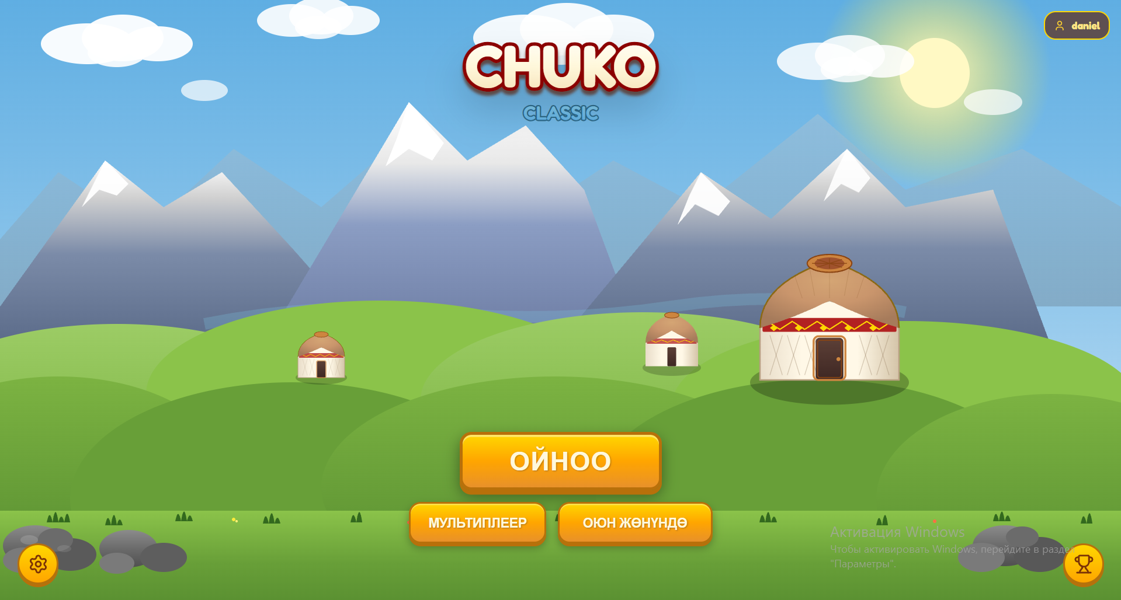
Figure 1: Title Screen
Description: The game opens on a full-width panoramic Kyrgyz mountain landscape. "CHUKO ARAKET" is displayed in bold stylized text over the image. A 3D-rendered chuko bone floats on the left side. Menu buttons for single-player, multiplayer, and instructions are centered on screen.

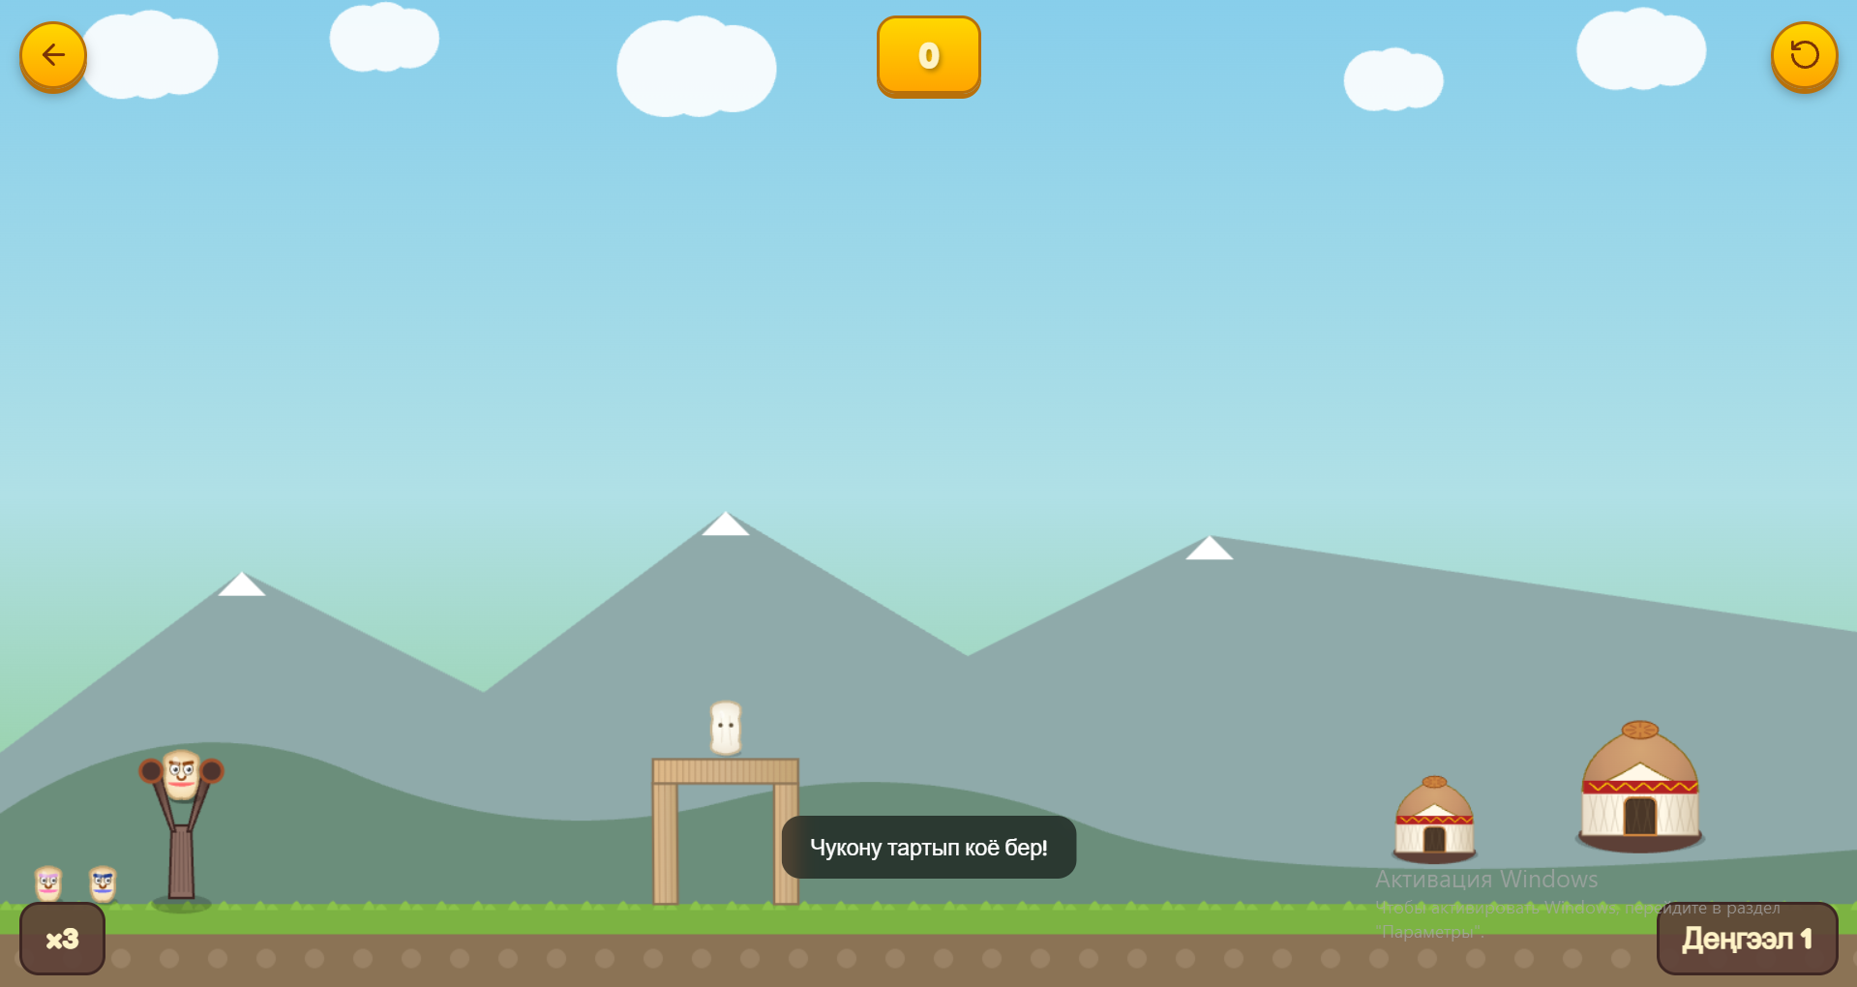
Figure 2: Gameplay (Mid-Shot)
Description: The slingshot occupies the lower-left area. The player has pulled back a red Ata-chuko and the dotted trajectory arc is visible, curving upward and to the right toward a stack of target chuko on a platform. The score counter and remaining shots are shown in the top UI bar. A Kyrgyz alpine valley fills the background.
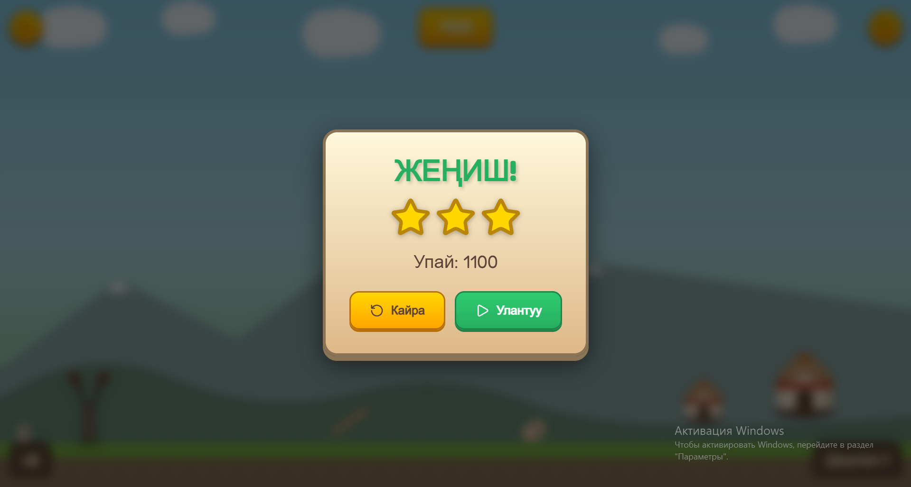
Figure 3: Level Complete Screen
Description: After clearing all targets, a completion screen shows the level number, score achieved, stars earned (based on shots remaining), and a cultural fact card with a brief text about Kyrgyz tradition. A "Next Level" button advances the game.
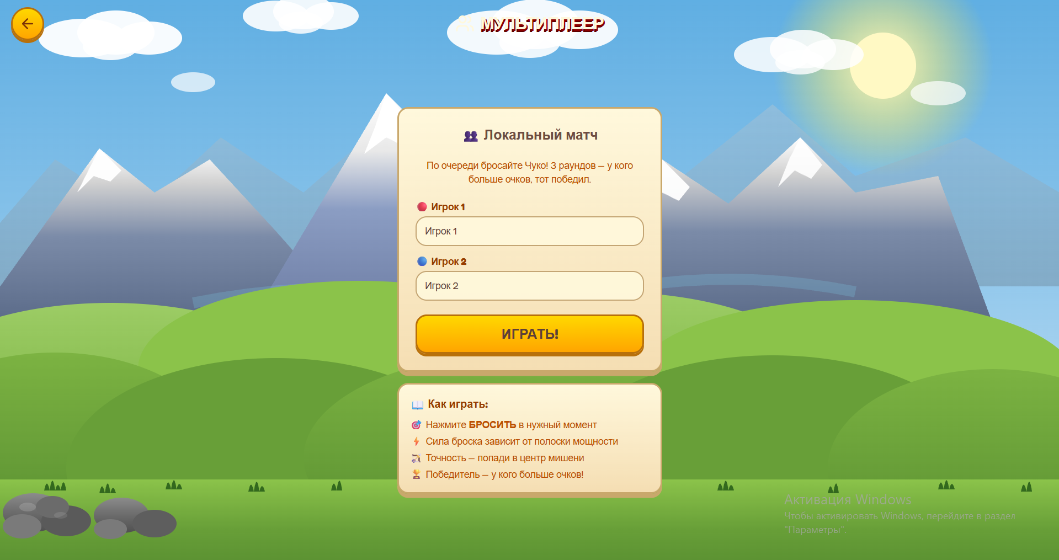
Figure 4: Multiplayer Lobby / Game
Description: Two players connected in the same session. The screen shows both players' scores, whose turn it is, and the shared level layout.

7. CONCLUSION & FUTURE SCOPE

7.1 Summary
Chuko Araket v1.0 is a working, publicly deployed browser game that successfully achieves its two core goals: it is genuinely fun to play, and it is authentically rooted in Kyrgyz cultural heritage. The physics-based slingshot mechanic works as intended - players aim, fire, and feel the satisfying crunch of a well-placed shot knocking targets off their platforms. The cultural layer - the landscapes, the ornaments, the music, the educational moments between levels - gives the game an identity that sets it apart from anything else in this space.
The four chuko types with distinct properties, the progressive level difficulty, and the multiplayer mode all made it into the final build. The game is live at chuko-4s24.vercel.app and accessible to anyone without installation.
This is a project the team is proud of - but it is also clearly a first version. The roadmap for v2.0 is substantial, and the foundation built here is solid enough to support it.

7.2 Challenges
Physics feel vs. physics accuracy - early in the project, the team tried to implement physically accurate projectile motion. The result felt wrong - too fast, too flat, unintuitive. The lesson learned was that in games, "feels right" always beats "is correct." The gravity, launch power scaling, and collision response were all deliberately tuned away from physical reality to feel satisfying. Finding the right values took more time than expected.
Collision detection at high velocity - a classic problem in 2D game physics. When a chuko is moving very fast (Ok-chuko especially, with its velocity multiplier), it can theoretically skip over a thin platform between one frame and the next without triggering a collision. This happened in early testing and caused frustrating moments where a shot would clearly pass through a platform with no effect. The fix was to reduce the physics timestep for high-velocity objects so collisions are checked more frequently. Not a trivial implementation for beginners.
Coordinating four developers on the same codebase - with four people working on different parts simultaneously (one on physics, one on UI, one on level design, one on multiplayer), merge conflicts were a regular occurrence. Trello helped with task assignment, but the team still had to navigate situations where changes to shared files like game.js conflicted. Establishing clearer file ownership conventions earlier would have saved time.
Multiplayer state synchronization - real-time multiplayer is one of the hardest problems in web development. The team's first approach - trying to sync full physics state between clients every frame - was too ambitious and created laggy, inconsistent experiences. Switching to an event-based model (sync actions rather than state) was the right call and stabilized the multiplayer mode significantly.
Cultural authenticity vs. game design - there was a real creative tension between wanting the game to be educationally accurate to the real Chuko game and wanting it to be mechanically fun. Real Chuko is a throwing game with specific rules about distances, bone types, and scoring that do not translate directly to a 2D side-scrolling canvas game. The team made deliberate decisions to adapt rather than replicate — keeping the cultural vocabulary (bone names, visual style, narrative) while building a game structure that works well in a browser. This is the right approach, but it required confidence to diverge from the source material.

7.3 Future Improvements - Version 2.0
Баатыр (Baatyr) character - a Kyrgyz warrior character was planned as the player avatar and visual anchor for the story. In v2.0, Baatyr will appear in cutscenes, react to good and bad shots, and give the game a narrative thread connecting the levels.
Expanded level system - v1.0 has a limited number of levels. Version 2.0 will add significantly more, with themed level packs (mountain pass, riverside camp, market square) each with their own visual style and unique obstacle types.
Enhanced graphics - the current visual implementation is functional but not polished to the level the moodboard envisioned. v2.0 will invest more in animated backgrounds, particle effects for successful hits (satisfying explosion of bones), and smoother chuko animations.
Full settings menu - players should be able to toggle music on/off, adjust volume, switch language, and reset progress. None of this exists in v1.0.
User accounts with persistent progress - right now, scores are not tied to a persistent identity. v2.0 will introduce user accounts so players can save progress, see their level history, and appear on leaderboards.
Richer multiplayer - the current multiplayer is functional but basic. v2.0 will expand this into a proper competitive mode with matchmaking, turn timers, and a ranking system.
More chuko types - the four types in v1.0 (Ata, Ok, Sek, Ak) were designed from a game design document but all could be developed further. New types could introduce special abilities - a split shot, a heavy boulder-type, or a curving trajectory.
Mobile optimization - the slingshot aiming mechanic needs rethinking for touchscreen. A pull-and-release that works well with a mouse becomes awkward when a finger obscures the aim. An alternative aiming UI (like a power/angle slider) will be explored for mobile v2.0.

8. REFERENCES & APPENDICES

8.1 References
MDN Web Docs - Canvas API: https://developer.mozilla.org/en-US/docs/Web/API/Canvas_API
MDN Web Docs - requestAnimationFrame: https://developer.mozilla.org/en-US/docs/Web/API/Window/requestAnimationFrame
Vercel Documentation: https://vercel.com/docs
Trello: https://trello.com
Traditional Kyrgyz Games - cultural reference material on альчики / Чуко
Kyrgyz ornamental art and узоры - visual reference for UI design

8.2 GitHub Repository
Source Code: https://github.com/danieltokt/Chuko/tree/main

8.3 Live Deployment
Play the game: https://chuko-1vmw.vercel.app/
Note: The game is actively being developed. The deployed version represents the current state of v1.0 and will continue to be updated as the team works toward v2.0.

